OS Lab 2

11762 Muhammad Kashif

Task 1

#include<stdio.h>

int main(){

int num = 0;

int num2;

int div;

int result;

char letter;

char array[6];

printf("Enter 5 numbers :\n");

for (int i = 0; i <= 4; i++){

scanf("%d",&array[i]);}

for (int i = 0; i <= 4; i++){

if(num < array[i])

{num = array[i];}}

printf("Highest number is %d",num);

return 0;}

OutPut

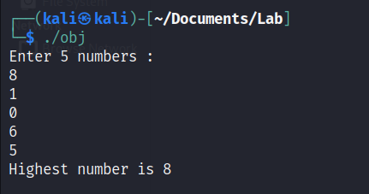

Task 2

#include<stdio.h>

int main(){

int num;

int num2;

int div;

float result;

printf("Kashif\n");

char star = '\*';

for(int i = 5; i> 0 ; i--){

for(int j = i; j> 0 ; j--){

printf("%c", star);}

printf("\n");}return 0;}

Output

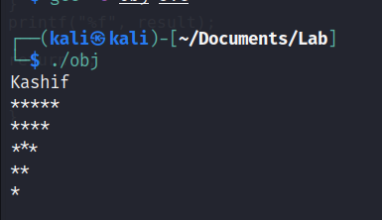

Task 3

#include<stdio.h>

int main(){

int num;

int num2;

int div;

float result;

printf("Kashif\n");

printf("Please enter 2 integer: \t");

scanf("%d %d", &num, &num2);

result = num % 2;

if (result == 0){

result = num2 % 2;

if (result == 0){

result = num + num2;}

else{

result = num \* num2;}}

else{

result = num \* num2;}

printf("%f", result);

return 0;}

Output

